A

# Project Report

On

# “Bhojanalya”

Submitted by

**Mohit Kumar Singh** (22734)

**Shantanu Kumar** (22750)

**Umang Varshney** (22760)

**Vidushi Gupta** (22761)

**S**ubmitted to

## Prof. A. K. Tiwari Prof. Neetika Gond

For Partial Fulfilment of Award of Degree In

# Masters In Computer Application

at



Department of Computer Science & Engineering

## Kamla Nehru Institute of Technology, Sultanpur

Affiliated to Dr. A.P.J. Abdul Kalam Technical University, Lucknow Session 2023-2024

# Declaration

We hereby declare that this submission is our own work and that, to the best of our knowledge and belief, it contains no material previously published or written by another person or material which to a substantial extent has been accepted for the award of any other degree or diploma of the University or other institute of higher education, except where due acknowledgement has been made in the text.

### Signature

Mohit Kumar Singh (22734)

Shantanu Kumar (22750)

Umang Varshney (22760)

Vidushi Gupta (22761)

# Certificate

It is to Certify that **Mohit Kumar Singh** (Roll No. 22734), **Shantanu kumar** (Roll No. 22750), **Umang Varshney** (Roll No. 22760) and **Vidushi Gupta** (Roll No. 22761) have carried out the project work presented in this project report entitled **“Bhojanalya”** for the award of master’s in computer application from Department of Computer Science and Engineering, Kamla Nehru Institute of Technology, Sultanpur under my guidance. The project report embodies results of original work, and studies are carried out by the students themselves and the contents of the project report do not form the basis for the award of any other degree to the candidates or to anybody else from this or any other University/Institution.

Supervisor Signature Supervisor Signature

(Mr. A. K. Tiwari) (Mrs. Neetika Gond)

HOD Signature

(Dr. Awadhesh Kumar)

# Acknowledgement

After bowing our heads in front of almighty god, we take this opportunity to thank all the people who have continuously worked for the betterment and successful completion of this project. We would like to express our gratitude in the following order:

First and foremost, we would like to pay sincere thanks to the Director of Kamla Nehru Institute of Technology for providing us with a conducive academic environment and for enabling us to pursue our academic aspirations.

We extend our gratitude to Dr. Awadhesh Kumar, our Head of Department, Computer Science and Engineering, for his support and guidance throughout the project.

We would like to express our deepest gratitude to Prof. A. K. Tiwari and Prof. Neetika Gond, Department of Computer Science and Engineering, Kamla Nehru Institute of Technology, Sultanpur, for their constant motivation and guidance. Without their support and encouragement, this project would have been a distant dream.

Furthermore, we would like to thank the entire staff of the department for their continuous support, guidance, and suggestions.

Lastly, we would like to thank our parents, whose unwavering love and support have been a constant source of strength for us. We are forever grateful for their encouragement and guidance.

# Abstract

The Bhojanalya android application aims to address the dietary needs and scheduling challenges of hostel students by providing a user-friendly mobile application with a slot booking feature. This app will enable students to order meals according to their preferred time slots, ensuring timely delivery or pickup. With a focus on convenience and customization, the app allows users to personalize their meal preferences, including dietary restrictions and allergies. Through seamless payment integration and intuitive interfaces, the app aims to streamline the food ordering process, enhancing the dining experience for hostel residents. By prioritizing accessibility, affordability, and user satisfaction, the Hostel Food App project seeks to become an essential tool for students living in hostels, facilitating their access to nutritious and delicious meals while navigating their busy academic schedules

# Table of Contents

Declaration… ii

Certificate iii

Acknowledgment… iv

Abstract. v

List of figures viii

List of tables… ix

Introduction… 1

Problem Statement… 1

Issues… 2

Objective 3

Literature survey… 5

Implementation… 9

Software requirement specification… 9

Project modules… 10

Data flow diagram… 10

ER diagram… 12

Use case Diagram… 13

Flow diagram………………………………………..……………………………………...14

Testing… 22

Stability… 23

Performance 24

Accessibility… 24

Security and trust… 26

Conclusion… 27

Future scope 28

Reference 29

# List of Figures

Figure 3.1 0 – Level Data Flow Diagram 10

Figure 3.2 1 – Level Data Flow Diagram 11

Figure 3.3 ER Diagram of Bhojanalya 12

Figure 3.4 Use Case Diagram of Bhojanalya 13

Figure 3.5 Flow Diagram of Bhojanalya 15

Figure 3.6 Screenshot of Customer Registration, Restaurant registration and Customer login 16

Figure 3.7 Screenshot of Restaurant login, Home page and Splash Screen… 17

Figure 3.8 Screenshot of Customer and Restaurant Forget Password and Login with phone 18

Figure 3.9 Screenshot of Customer Home page, Payment and Restaurant home Page 19

Figure 3.10 Screenshot of Job Add and Restaurant Profile Update… 20

Figure 3.11 Screenshot of Menu Update 20

Figure 4.1 Screenshot of Stability of Test Devices… 23

Figure 4.2 Screenshot of Performance of Test Device 24

Figure 4.3 Screenshot of Touch Target size 25

Figure 4.4 Screenshot of Implementation… 25

Figure 4.5 Screenshot of Low Contrast… 26

# Chapter 1 Introduction

The Bhojanalya App is a comprehensive digital platform designed to streamline and enhance the management of various PG activities, with a particular focus on food-related services. The App's primary objective is to provide an efficient system for managing student information, Restaurants details, monthly bills, and Food Menu. It also tracks the number of students and their availability.

The App's core feature is its sophisticated Food management system. This system allows for the calculation of monthly mess bills, ensuring transparency and accuracy in billing. It also includes a feature that enables students to use their allocated ID numbers to access the mess within a limited time slot. At the end of each month, a detailed Food bill is issued to each student's ID, outlining their meal details and any outstanding dues. Students and Other Peoples are then given a 10-day window to settle their dues.

In addition to its mess management capabilities, the Hostel Food App also offers a range of other features designed to improve Food and Health administration. These include a Healthy Diet allocation system, a Diet Chart module, and a system for tracking student and people’s Health. The App also provides a platform for managing Daily Food Requirements, further enhancing its utility as a comprehensive Food Management System.

The Bhojanalya App is designed to reduce manual choosing of Menu and improve efficiency within the Persons to choose their Desired Food by themselves. By digitizing and automating many of the tasks traditionally associated with Food management, the App allows for quicker, more accurate administration. Furthermore, it provides a valuable resource for students, offering them an easy-to-use platform for managing their Restaurants-related activities.

In summary, the Bhojanalya App is a robust, user-friendly platform that brings together a range of features to simplify and enhance the management of Food and daily activities. With its focus on food-related services, it offers a unique solution to the challenges of Time Management, making it an invaluable tool for both PG students and Outsiders alike.

## Problem Statement

* The job market for daily wage "Inefficient and inconvenient food delivery systems in hostel environments often lead to students facing challenges in accessing timely and customizable meal options. Traditional meal delivery methods lack flexibility in catering to individual schedules, resulting in long wait times or missed meals. Additionally, limited options for dietary preferences and the absence of a streamlined booking process contribute to dissatisfaction among hostel residents. Thus, there is a pressing need for a comprehensive solution that addresses these issues by introducing a hostel food app with a slot booking feature. This app aims to revolutionize the dining experience for hostel students, offering a convenient platform for ordering meals according to personalized schedules, dietary requirements, and preferences, ultimately ensuring timely and hassle-free access to nutritious and affordable food."
  1. **Issues**

As with any project, there are potential issues and challenges that may arise during the development and implementation of the Bhojanalya android application. Some of these issues include:

* + - **Slot Management**: Efficiently managing and optimizing available slots to accommodate fluctuating demand patterns, varying meal times, and user preferences can be complex, requiring sophisticated algorithms and real-time updates.
    - **Customer Support**: Providing responsive and effective customer support to address user queries, resolve issues, and handle feedback promptly is essential for fostering user satisfaction and loyalty.
    - **Supply Chain Management**: Coordinating with multiple food vendors, managing inventory, and ensuring timely deliveries while maintaining food quality and safety standards pose logistical challenges that need to be addressed effectively.
    - **Regulatory Compliance**: Adhering to local regulations, licensing requirements, and food safety standards, as well as addressing legal and compliance issues related to online food delivery services, is necessary to operate the app legally and ethically.
    - **Market Competition**: Competing with established food delivery platforms and other similar services in the market requires innovative features, targeted marketing strategies, and continuous improvement to differentiate the app and attract users.
    - Addressing these issues will be critical to the success of the project and will require careful planning, execution, and ongoing monitoring and evaluation.

## Aim and Objectives

**Aim**

The aim of the Bhojanalya android application is to create a user-friendly and efficient platform with a slot booking feature to provide a convenient and solution for hostel students to order meals according to their schedules and preferences. By implementing a slot booking system, the app aims to streamline the dining experience, allowing users to reserve specific time slots for meal deliveries or pickups. The primary goal is to ensure that students can easily access nutritious and affordable meals while accommodating their busy academic and extracurricular schedules. Additionally, the app aims to offer customization options, such as dietary preferences and allergy information, to cater to the diverse needs of its users. Through intuitive user interfaces and seamless payment integration, the app seeks to enhance user satisfaction and engagement, ultimately becoming the go-to platform for hostel residents to fulfill their food requirements conveniently and reliably

## Objective

In the bustling world of hostel living, finding satisfying and affordable food options can be a challenge. Bhojanalya was born out of a desire to make hostel life more enjoyable and delicious. We have curetted a one-stop digital haven for hostel residents, where they can discover, share, and relish the best culinary experiences right within their budget.

Bhojanalya goes beyond just meal delivery. The app promotes community and engagement by featuring user-generated reviews, ratings, and food photos. Students can connect with fellow students and individuals who share similar dietary preferences, building a virtual support system and discovering new culinary experiences.

In 'Bhojanalya' Students create their profile, inputting their dietary preferences, nutritional requirements, and budget constraints. The app's intelligent algorithm instantly generates a list of restaurants that match their criteria. With just a few taps, Student can place their order, schedule delivery, and even track the preparation and delivery process in real-time.

# Chapter 2 Literature Survey

Here From a student's perspective, Swiggy and Zomato are two popular food delivery apps that offer a wide range of food options with variety of Menu. Here are some pros and cons of both platforms:

## Challenges in Small Cities:

Restaurants services and online Channels, which have thrived in metropolitan areas, encounter distinct challenges when expanding their operations to smaller cities. The key challenges identified include:

## Pros of Swiggy and Zomato:

* **Vast Restaurant Network:** Swiggy/Zomato has a wide network of restaurants and eateries, providing students with a diverse range of food choices, from local favorites to international cuisines.
* **Quick Delivery:** Swiggy/Zomato is known for its fast delivery services, which is particularly advantageous for students who may have limited time between classes or study sessions.
* **Discounts and Offers:** Swiggy/Zomato frequently offers discounts, cashback deals, and promotions, making it more affordable for students on a budget.
* **Live Order Tracking:** The app allows users to track their orders in real-time, so students can plan their activities accordingly.
* **User-Friendly Interface:** Swiggy's/Zomato app is intuitive and easy to navigate, making it convenient for students to place orders quickly.

## Cons of Swiggy and Zomato:

* **Delivery Times:** Zomato's delivery times may sometimes be longer compared to Swiggy, which can be inconvenient for students looking for quick meals.
* **Delivery Charges:** Similar to Swiggy, Zomato may charge delivery fees, which can increase the cost of the meal.
* **Promotions:** Zomato's discounts and promotions may not be as frequent as Swiggy's, making it potentially less budget friendly.
* **Order Accuracy:** While user reviews can be helpful, there may be instances of order accuracy issues with some restaurants.

This literature survey was conducted based on information available on the Apps and app stores of the respective applications**.**

### Comparison

In comparison with other job search platforms, the Daily wage worker platform has several advantages on these features which are as follows:

1. **Slot Booking Feature**:
   * Bhojanalya: Offers slot booking functionality, allowing users to reserve specific time slots for meal deliveries or pickups, catering to the fixed schedules of hostel students.
   * Other Food Apps: Typically, do not offer slot booking features, catering more broadly to general consumers who may not have fixed meal times.
2. **Customization for Hostel Environment**:
   * Bhojanalya: Tailored to the needs of hostel students, offering options to accommodate dietary restrictions, allergies, and meal preferences commonly found in the hostel environment.
   * Other Food Apps: Offer general customization options but may not specifically cater to the unique requirements and preferences of hostel residents.
3. **Affordability**:
   * Bhojanalya: Focuses on providing affordable meal options suitable for students' budgets, potentially offering special discounts or loyalty programs tailored to their financial constraints.
   * Other Food Apps: Offer a range of restaurants and price points, catering to various budgets but may not emphasize affordability specifically for students.

# Chapter 3 Implementation

## Software Requirement Specification

### Hardware Requirements

The application will be designed to run on Android devices with the following minimum hardware specifications:

**Client**

* + - Smartphone with processor 4.4 Snapdragon 450 or higher.
    - RAM : 4 GB
    - Storage : 8 GB

**Developer**

* + - Processor : Core i5-8400 3.0 GHz
    - RAM : 8 GB
    - Storage : 100 GB

### 3.1.2 Software Requirements

The application will be developed using Java programming language and the Android Studio Integrated Development Environment (IDE).

**Client**

* Operating System : Android 7 or above

**Developer**

* Development Environment : Android Studio
* Database : Firebase
* Operating System : Windows 10
* Documentation tool : MS Word, MS PowerPoint

## Project Modules

1. **Registration and login module:** This module enables both customers and Restaurant to create a new account and login to the platform. The registration process requires users to enter their personal details, such as name, email address, contact number, and preferred username and password. The module also includes features such as email verification and password reset.
2. **Homepage module:** This module serves as the landing page of the application and provides an overview of the platform's features and services. The homepage includes a search bar for users to search for food option and restaurant, as well as links to the registration and login pages for both customers and Restaurant. The module also includes a section for featured food options.
3. **Payment dashboard module:** This module provides an interface for customers and restaurants to manage their payment transactions. The payment dashboard includes features such as payment history, payment requests, and payment verification. Restaurants can request payment for their completed orders, while customers can verify the completion of the order and approve the payment. The module also includes a secure payment system that enables users to make and receive payments using various payment methods.

## Data Flow Diagram

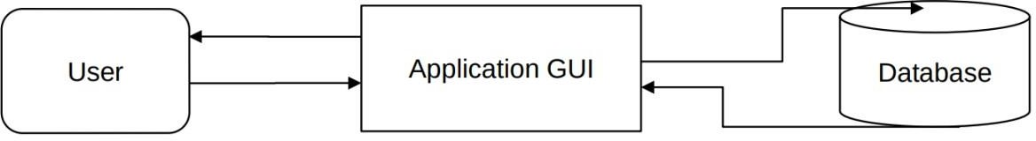

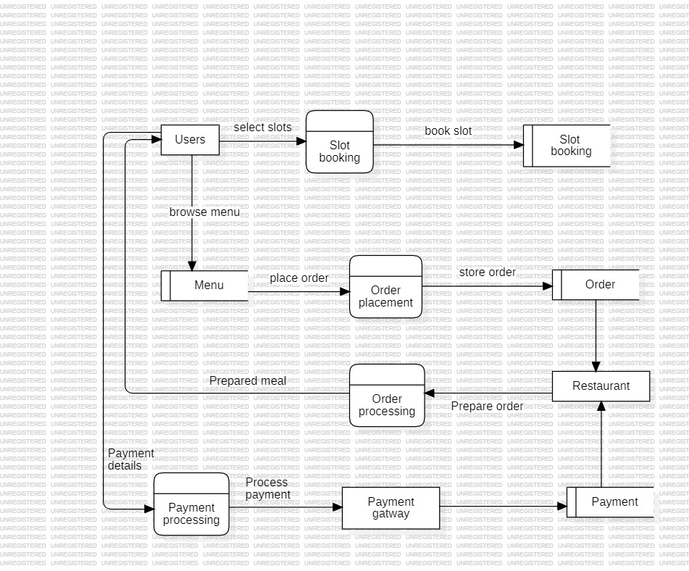

Figure 3.2 1 – Level Data Flow Diagram

## ER Diagram

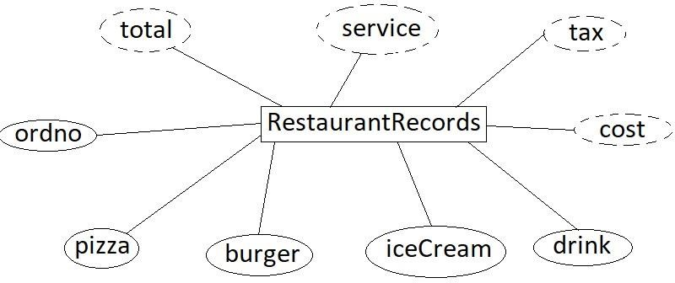

Fig.3.3 ER Diagram restaurant records table

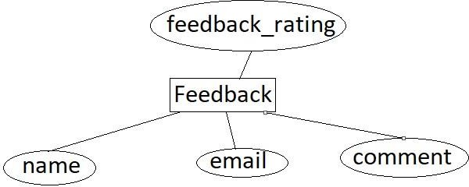

Fig.3.4 ER Diagram of feedback table

## Use Case Diagram

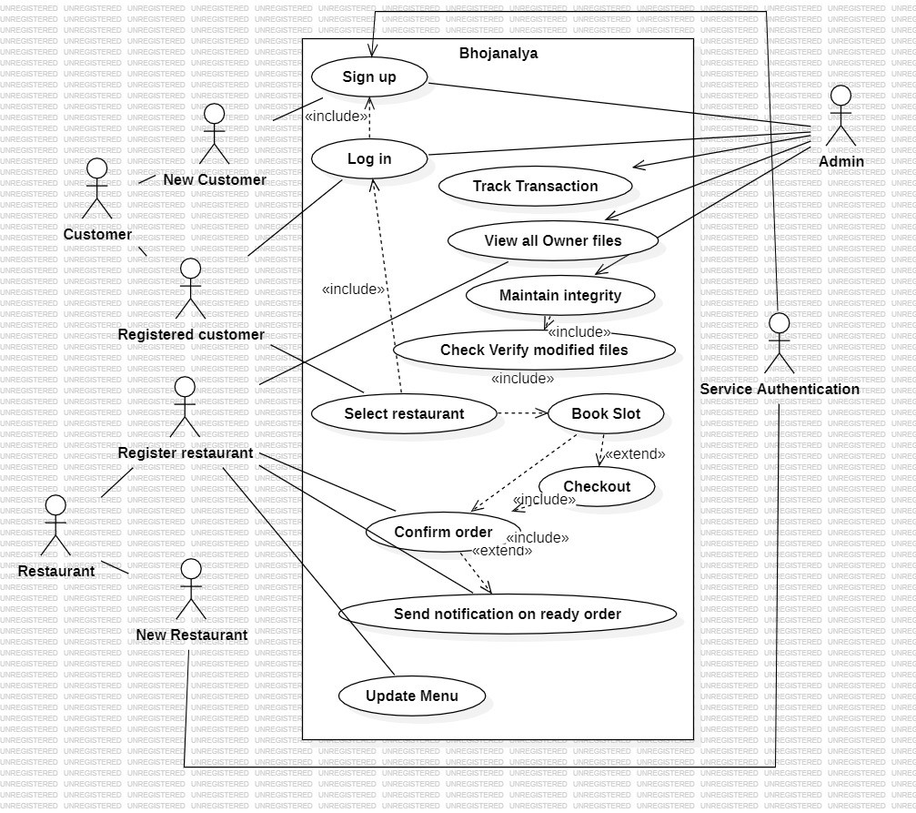

Figure 3.4 Use Case Diagram

## Process Flow Diagram

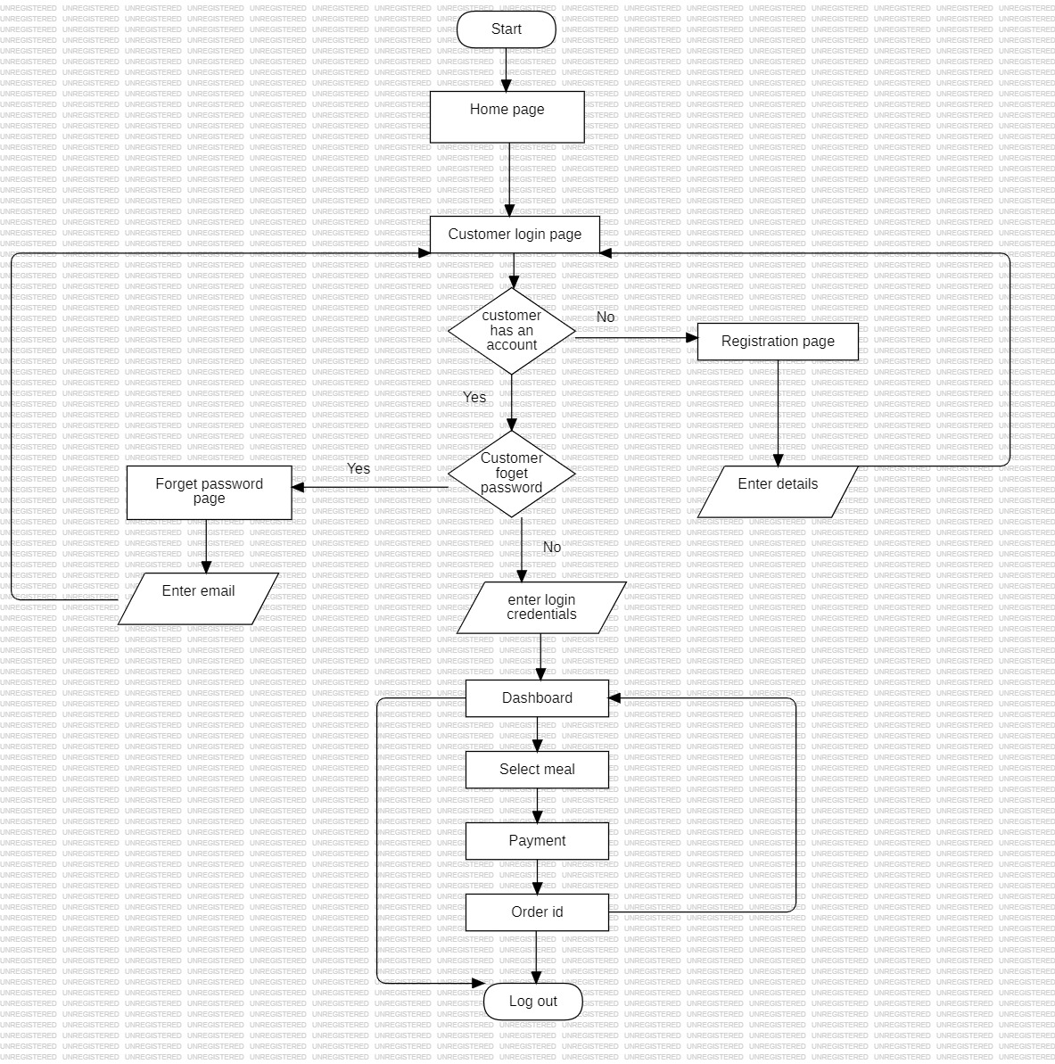

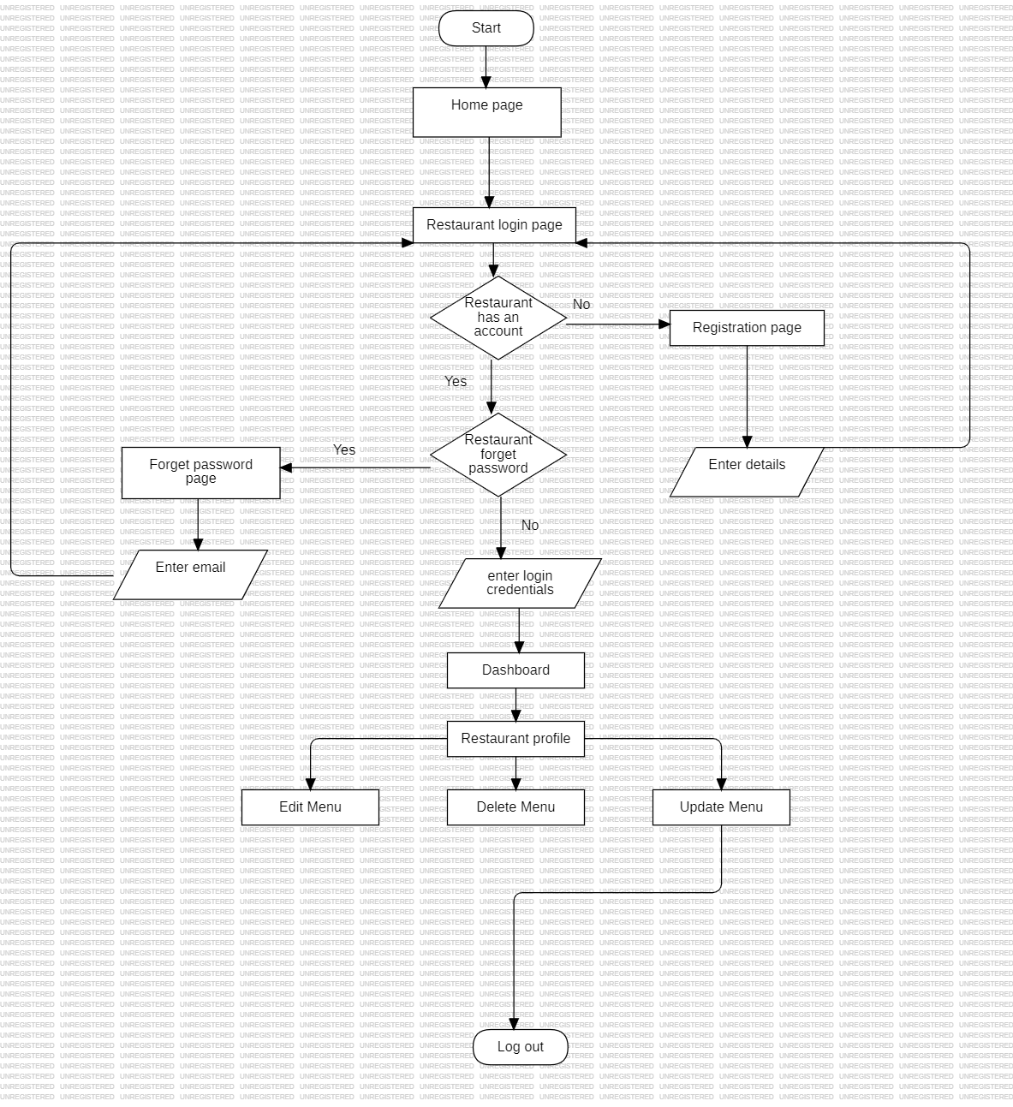

Fig. 3.5 process flow diagram

### 3.7 Page Description

1. **Customer Registration:** This module allows new customers to sign up and create an account on the platform. Customers can provide their personal details, such as name, email, and contact information, and set up a password to access the platform's features. Once registered, customers can log in to their account to search and order meals in the available slot.
2. **Restaurant Registration:** This module enables new restaurants to sign up and create an account on the platform. Restaurant owners can provide their personal details, such as name, email, and contact information, and set up a password to access the platform's features. Once registered, restaurants can log in to their account to post available food options and manage orders.
3. **Customer Login:** This module allows registered customers to log in to their account and access the platform's features. Customers can view available restaurants, order meals, and manage their bills and payments. This module also ensures that customer data is secure and accessible only to authorized users.

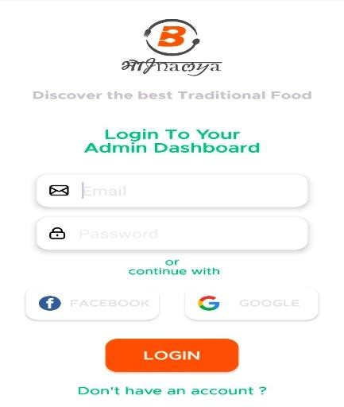

Figure 3.6 Screenshot of Customer Registration, Agent registration and Customer login

1. **Restaurant Login:** This module allows registered restaurants to log in to their account and access the platform's features. Restaurant can post available food options, available slots

and collect orders. This module also ensures that restaurants data is secure and accessible only to authorized users.

1. **Home Page:** This module is the main landing page of the platform, which provides an overview of available food options and allows users to navigate to other pages. The home page typically includes search functionality, featured food listings, and links to other important pages on the platform.
2. **Splash Screen:** This module is the initial screen that users see when they open the platform. The splash screen typically displays the platform's logo or other branding elements and provides a brief introduction to the platform's features.

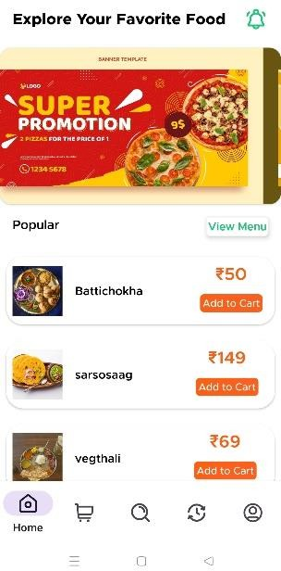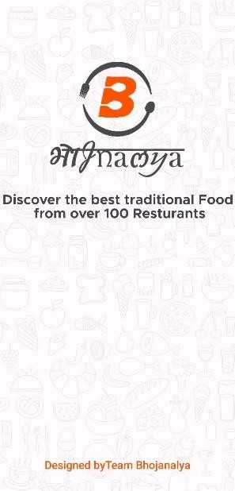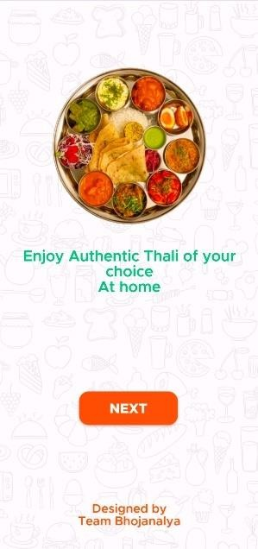

Figure 3.7 Screenshot of Home page and Splash screen and Start activity

1. **Login with E-mail:** This module allows users to log in to their account using their phone number, rather than their email address. This feature provides an additional layer of security and convenience for users who prefer not to use their email address for authentication.
2. **Customer Home Page:** This module is the main landing page for customers after they log in to their account. The customer home page typically displays food recommendations, and other important information for the user.
3. **Payment:** This module allows customers to make payments for services offered on the platform, such as order charges. The payment module typically supports various payment methods, such as credit cards, debit cards, or online payment platforms like Razor Pay.
4. **Restaurant Home Page:** This module is the main landing page for agents after they log in to their account. The agent home page typically displays the food options posted by the restaurant, order status for each order, and other important information related to the restaurant's account.

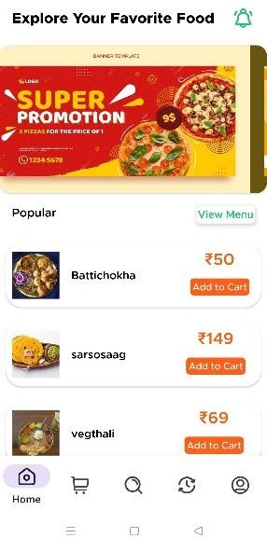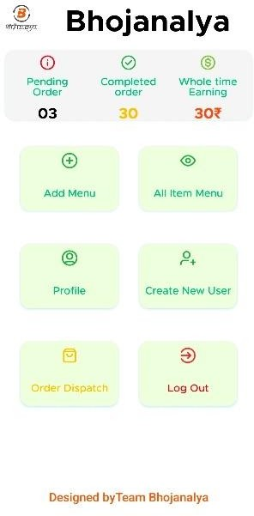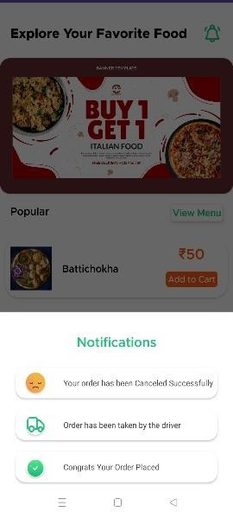

Figure 3.9 Screenshot of Customer Home page, Restaurant Home page and Notification

1. **Add menu:** This module allows restaurants to add new food items to their menu on the platform. The food item add module typically includes fields for food item name, description, Price, and other relevant information.
2. **Food Item Delete:** This module allows agents to delete their existing food item listings from the platform. This module ensures that the platform only displays up-to-date menus and relevant food items listings to customers.
3. **Restaurant Profile Update:** This module allows restaurants to update their personal details and account settings, such as contact information, password, and payment preferences. The restaurant profile update module ensures that the restaurant's information is accurate and up to date, which helps to facilitate smooth communication between restaurants and customers.

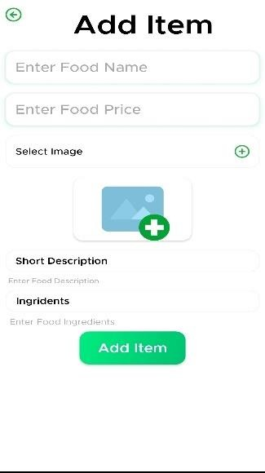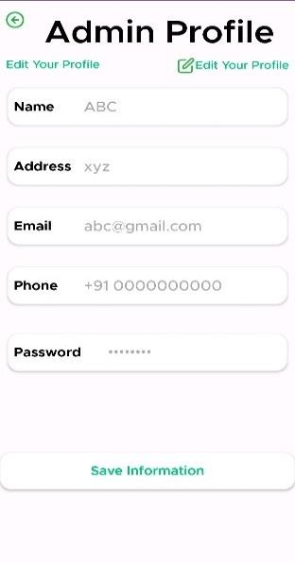

Figure 3.10 Screenshot of Food Item Add and Agent Profile Update

## 3.8. Deployment of project

Our application can be downloaded and installed from google play store and you can check the source code by clicking on the following link:

<https://github.com/mohitkumar0502/Bhojanalya-Webapp>

# Chapter 4

# Testing

To test our application, we have used several testing methods to ensure its functionality, performance, accessibility, and security.

Here, we do two different types of testing

1. Alpha and Beta testing
2. Through Google Play Console

## Alpha and Beta Testing

Firstly, during the development phase, we conducted alpha testing, which involved testing the application in-house by our development team. This testing method helped us identify and resolve any issues that arose during the development process before releasing the application for further testing.

After alpha testing, we conducted beta testing, which involved releasing the application to a select group of external testers to evaluate the application's performance, usability, and functionality. This testing method helped us gather valuable feedback and identify any remaining issues or bugs before releasing the application to the public.

## Through Google Play Console

Now we have published it on the Google Play store, where it underwent testing in two ways.

1. Internal Testing
2. User Rating

Testing data was collected from the Google Play Console. The testing data included various metrics such as the number of downloads, user engagement, and retention rate. This data was analyzed to identify any potential issues or areas for improvement in the app. Additionally, user feedback was also collected from the app's review section on the Play Store to gain further insights into the app's user experience. This data was taken into consideration to make necessary changes and updates to the app to enhance its performance and user satisfaction. Overall, the testing data provided valuable insights into the app's performance and helped to guide future development and improvements.

## Stability

Stability issues, for example when your app crashes or stops responding, affect the user experience. Fixing issues can improve your user metrics, such as app rating, installs, and retention.

**Crashes and ANRs:** Issues that caused your app to crash or stop responding. Fixing these issues can improve your user metrics, such as app rating, installations, and retention with this there were no issues found.

**Installations and start-up failures:** Issues that prevented your app from being tested. Check that these issues will not affect your production users with this there were no issues found.

**Defective libraries:** Library versions that have known defects. Your app has dependencies on these versions. If not updated, these defective library versions may cause your app to crash with this there were no issues found.

**Android compatibility issues:** Issues in your implementation which can degrade the user experience. Issues can include restricted API and double splash screen there is double splash screen warning

The crawler detected a blank screen or splash screen that is shown in your app before the system splash screen. Users launching your app on Android 12 or higher will see 2 splash screens.

To fix this issue, update your app to use the Splash Screen API.

### Test devices without issues

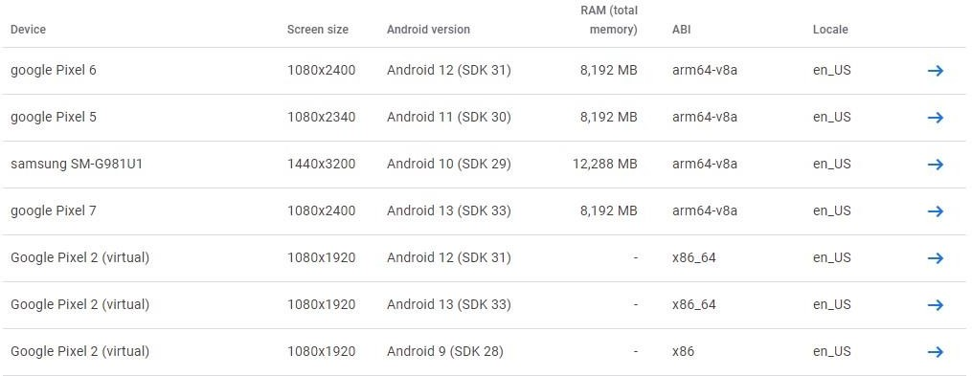

Figure 4.1 Screenshot of Stability of Test Devices

## Performance

Performance issues, for example slow startup and render times, affect the user experience. Fixing issues can improve your user metrics, such as app rating, installs, and retention.

**Slow rendering:** Percentage of the frames during the test that took more than 16ms to render with this there were no issues found.

**Cold start time:** Time taken by your app to launch for the first time after being installed on the specific device model.

2 devices with issues. Your app took 6,246ms to launch for the first time, after being installed on this device model. Your app took 6,803ms to launch for the first time, after being installed on this device model.

### Test devices without issues

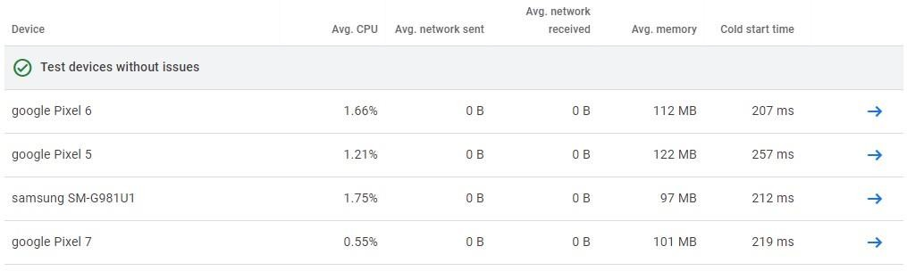

Figure 4.2 Screenshot of Performance of Test Device

## 4.2.3. Accessibility

Accessibility issues mean your app isn’t easy for everyone to use. Fixing issues can help you reach more users.

**Content Labelling:** After conducting a thorough assessment, it has been determined that there are no problems with the content labelling in your app. Specifically, all elements within the app have been correctly labelled to ensure accessibility for screen readers.

**Touch target size:** The number of elements in your app that don't meet the recommended touch target size.

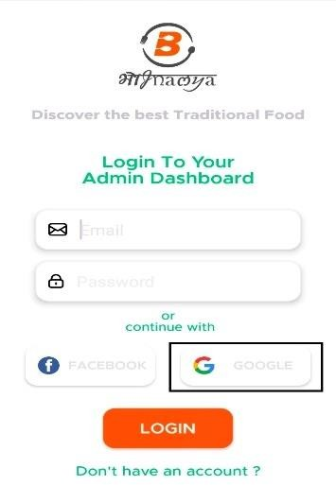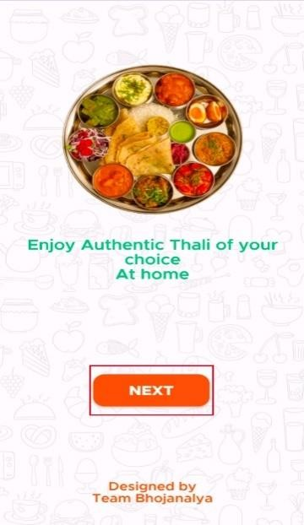

Figure 4.3 Screenshot of Touch Target size

Consider making the clickable item larger. This item's height is 20dp. Consider making the height of this touch target 48dp or larger.

**Implementation:** The number of layout issues in your app that can make it difficult to use for users with motor impairments with this 1 unique issue was found.

The item's text size unit is dip. Consider specifying the text size in scaled pixels (sp).

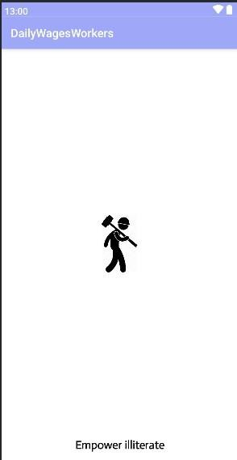

+

Figure 4.4 Screenshot of Implementation

**Low Contrast:** The number of low contrasts color issues in your app with this there are 14 unique issues found

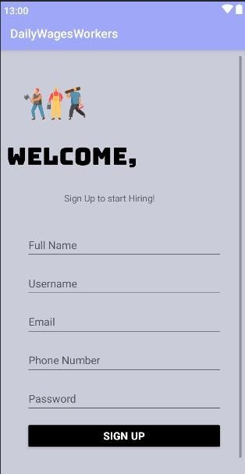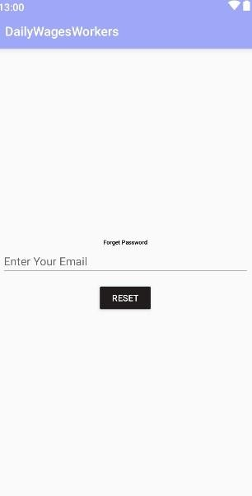

Figure 4.5 Screenshot of Low Contrast

Consider increasing the item's text foreground to background contrast ratio. The item's text contrast ratio is 2.92. This ratio is based on an estimated foreground color of #000000 and an estimated background color of #5A546D. Consider increasing this item's text contrast ratio to 3.00 or greater.

## 4.2.4. Security And Trust

Security vulnerabilities, including those in third-party libraries, can put you and your users at risk. Fixing issues can help protect users and your reputation with this there is no issue found.

# Chapter 5 Conclusion

In summary, the Bhojanalya App is a robust, user-friendly platform that brings together a range of features to simplify and enhance the management of Food and daily activities. With its focus on food-related services, it offers a unique solution to the challenges of Time Management, making it an invaluable tool for both PG students and Outsiders alike.

## Key points of Project

* + - **Comprehensive database:** The platform provides a comprehensive database of restaurants with different varieties of food options, enabling customers to search and find healthy and tasty food options quickly and efficiently.
    - **Slot booking:** Restaurants can availably slot timings of their restaurants and customers can book their slot according to their preference and plan their meal accordingly.
    - **Messaging system:** The platform offers a messaging system that enables the customers and restaurants to communicate and solve any queries about the order or the slot timing.
    - **Secure payment system:** The platform provides a secure payment system that protects both customers and restaurants from fraudulent activities.

# Chapter 6

# Future Scope

There is a vast scope for the future development of the Bhojanalya job portal android application. Some of the potential areas for improvement include the integration of artificial intelligence and machine learning algorithms for better food and restaurant recommendations, expansion to different geographical locations, and the inclusion of additional features such as rating and review systems for restaurants. With continued development and implementation of innovative features, the Bhojanalya android application has the potential to become a widely used and indispensable tool for people living away from home and restaurants owner.

Another version of our project may contain the following functionalities:

* + - **In-app messaging system:** The ability for customers and restaurants to communicate directly through the app, enabling faster and more efficient communication.
    - **Payment gateway integration:** The ability for customers to make payments to restaurants directly through the app, reducing the need for physical transactions and providing a more secure payment system.

# References

1. https://ijmra.in/v4i3/15.php
2. <https://core.ac.uk/download/pdf/38105891.pdf>
3. [https://developer.android.com/codelabs/basic-android-kotlin-compose-install-](https://developer.android.com/codelabs/basic-android-kotlin-compose-install-android-studio#1) [androidstudio#1](https://developer.android.com/codelabs/basic-android-kotlin-compose-install-android-studio#1)
4. https://www.researchgate.net/publication/321844341_Online_Food_Ordering_System5